# Ideation Phase

**Define the Problem Statements**

|  |  |
| --- | --- |
| Date | 19 November 2022 |
| Team ID | PNT2022TMID20305 |
| Project Name | Project – Estimate The Crop Yield Using Data Analytics |
| Maximum Marks | 2 Marks |

**Customer Problem Statement Template:**

Agriculture is important for human survival because it serves the basic need.A well-known fact that the majorityofpopulation(≥55%)inIndiaisinto agriculture. Due to variations in climatic conditions, there exist bottlenecksforincreasingthecropproductioninIndia. Ithasbecomechallengingtasktoachievedesired targetsinAgribasedcropyield.Variousfactorsaretobeconsideredwhichhavedirectimpactontheproduction.

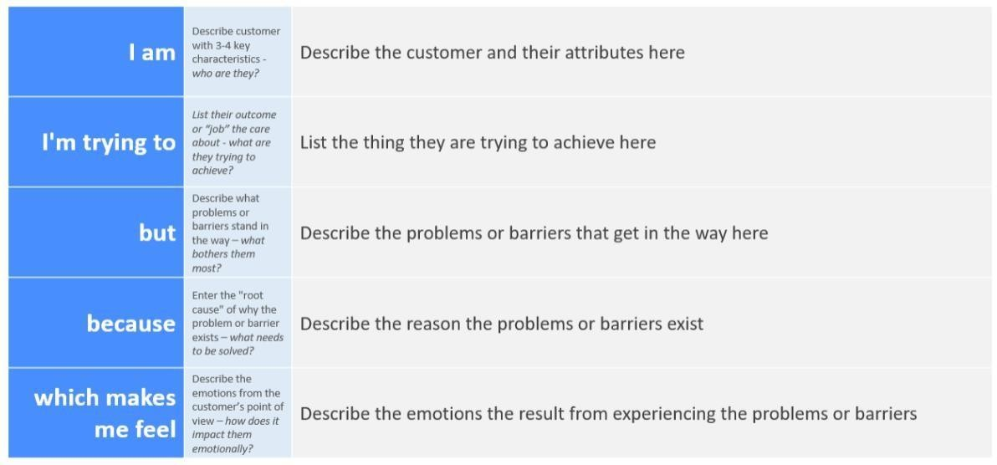

Reference: <https://miro.com/templates/customer-problem-statement/>

|  |  |  |  |  |  |  |  |
| --- | --- | --- | --- | --- | --- | --- | --- |
| **Example:** | | | | | | |  |
|  | **Problem Statement (PS)** | **I am (Customer)** | **I’m trying to** | **But** | **Because** | **Which makes me feel** |  |
| PS-1 | A farmer | Harvest my crops at right time | Various factors are  reduced the yield | Climate conditions | frustrated |  |
| PS-2 | A farmer | Use of technology in agriculture | various factors are to be considered which have direct  impact on production | insects affect the crops,low amount of water irrigation | disappointment |  |
|  | | | | | | |  |